NEWS RELEASE 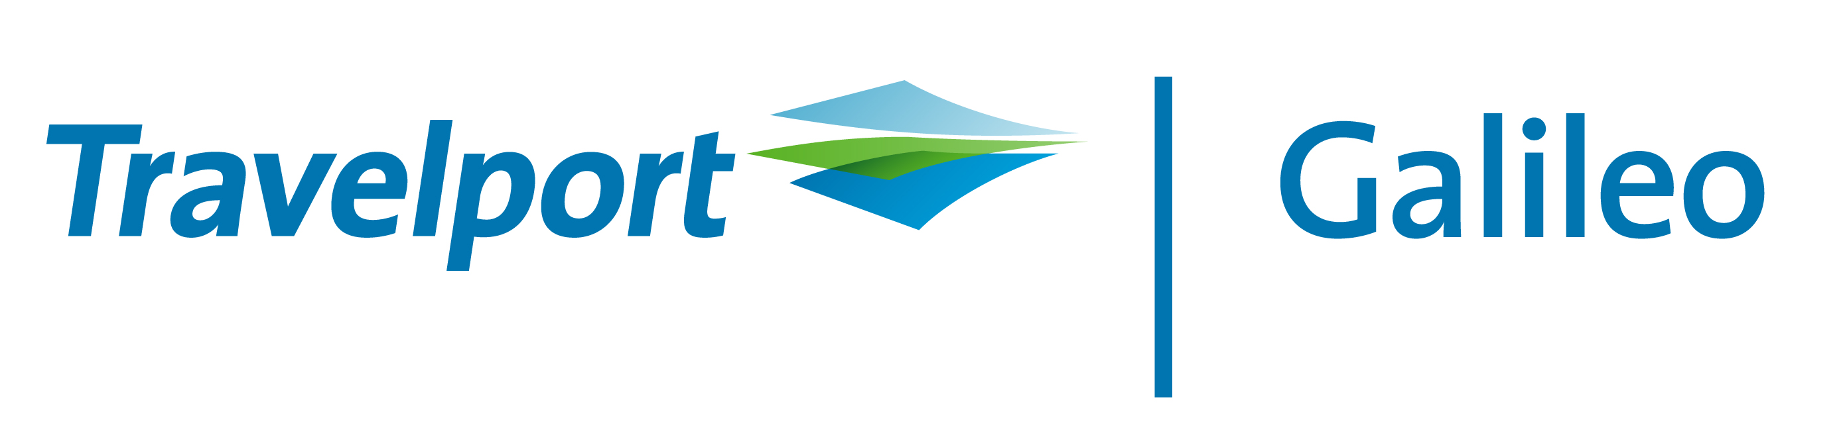

Galileo GDS Announces Agreement with Hermes i-Ticket to Provide Indian Rail Content

Galileo-connected agents can now book and issue Indian Railways tickets

July 26, 2010, New Delhi: Travelport’s Galileo, the global distribution system (GDS) that is officially distributed by InterGlobe Technology Quotient Ltd. (ITQ) in India, announces that it has reached a content agreement with Chennai-based Travel Technology solutions provider, Hermes i-Tickets Private Limited, to provide Indian Railways content on the booking system. Galileo-connected travel agents can now check schedules, book and issue rail tickets for their customers as an alternative to domestic air travel.

With passenger traffic on India’s trains growing around 8% annually, and approximately 300,000 people booking train tickets every day, access to rail content is important for travel agents and their customers. Galileo GDS offers agents an integrated approach to customer travel solutions with airline, car, hotel (including budget hotels) and now, rail inventory as well.

Mr. Marco Gorin, Chief Commercial Officer of InterGlobe Technology Quotient (ITQ), said, “Indian travellers will now have easier access to booking train tickets. This tie-up with Hermes will give our travel agent partners, spread across 412 cities , instant access to Indian rail content that is much in demand by travellers. This new content works well with our hotel offering that has been expanded recently to include more independent and regional hotels, giving an agent the ability to create a customised itinerary for their customers, no matter what their destination or mode of travel may be.”

Dr. Usman Fayaz, Chairman, Hermes i-Tickets Private Limited., said, “We are delighted to partner with Galileo and broaden the distribution of Indian Railways inventory via the Galileo GDS booking system. Through this alliance, Galileo-connected travel agents can book and issue rail tickets with a few simple clicks.”

Mr. M.V. Shastry, CEO, Hermes i-Tickets Private Limited said “This initiative will further strengthen the Galileo offering in India by providing travel agents with a one-stop-shop for content be it rail, hotels, insurance or other travel services.”

-end-

About Hermes and How the Hermes system works with the Galileo GDS

Hermes specializes in building GUI-based desktop applications for travel agents, which work seamlessly with the client server architecture and provides content across all forms of travel. These applications are robust and proven technologies, and above all, it is extremely user friendly. For users of the Galileo GDS, Hermes has developed a customized application, with enhanced GUI interfaces.

- Hermes connects to directly Indian Railways rail inventory server through multiple modes
- The Hermes client communicates with the Galileo host using the same proprietary protocol used on the Galileo Desktop for obtaining passenger information and recording booking confirmations with the Galileo host
- Galileo agents can actively use rail content and club rail bookings into the Galileo-generated PNR, and/or create an independent PNR for a rail booking done on Galileo.
- The PNR will automactically get integerated to Galileo’s back office functionality and various reports can be generated as required.

About InterGlobe Technology Quotient (ITQ)

Galileo is officially distributed in India by InterGlobe Technology Quotient (ITQ) – InterGlobe's exclusive travel technology company. ITQ is the key differentiator of the GDS in India and offers technology innovations like Galileo Alerts, E-Commerce, and ITQ Financials among a host of other business improvement and growth tools. Headquartered in Gurgaon, it has an extended network across 412 cities with 21 dedicated offices in India. Its 100% subsidiary, ITQ-Lanka manages the Galileo distribution in Sri Lanka. Company enjoys direct relationships with over 12,000 agency locations and has 11 training centres with state-of-the-art infrastructure and facilities matching international standards.

About Hermes I Tickets Private Limited:

Hermes I Tickets Private Limited is a Chennai based Travel Technology solutions and Distribution Company, operating since 2006 and one of the fastest growing company in this market space. Ease-Ticket is one of Hermes flagship product being used by the travel agents across India. Over the past three years Hermes has grown to become a trendsetter in the Travel Industry by bringing in cutting edge technology to provide simple and easy to use solutions for the travel Industry. Hermes is unique and only travel solutions provider in India offering a client based application tool for booking travel and beyond. Hermes has a widest range of travel product Inventory covering all forms of travel and related service with highest level of security and redundancy. Hermes travel products cover all kind of airlines inventories, Bus, Hotels, Car rentals, insurance and other travel related service other than railways. Hermes also gives access to non- travel products like utility bill payments, mobile top-ups and more such services.

For media queries, please contact:

Geetika Gulati @ 9289897231
geetika@wordswork.in

Sakshi Chaubey @ 9654684113
sakshi@wordswork.in

